Emergency Contacts
If possible, it is always best to contact the following parties in the event of an emergency (you can always call 9-1-1).
Phone Numbers:
Police, Fire, EMS 9-1-1
Non-Emergency Police phone number
County Hotel is located in is List County
Emergency Management
General Manager –
Assistant GM –
Chief Engineer –
Hospital Name –
Hospital Address –

1ST FLOOR (Insert your Hotel Floor Plan here)
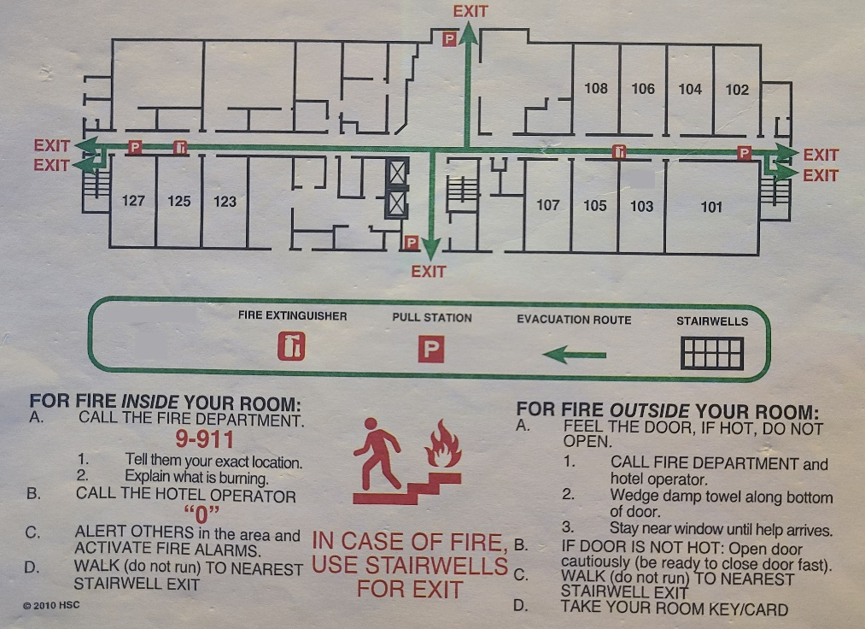
2ND FLOOR (Insert your Hotel Floor Plan here)

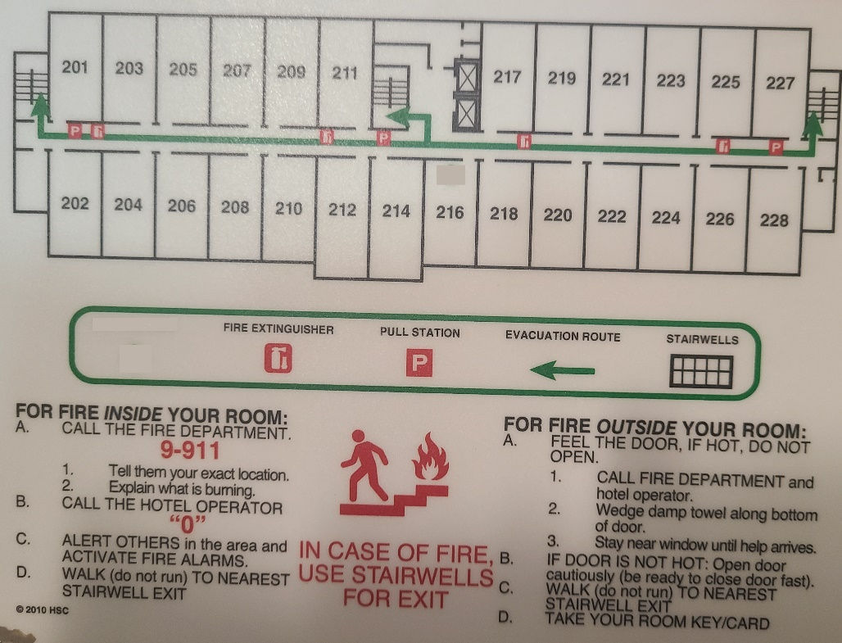

3RD FLOOR (Insert your Hotel Floor Plan here)

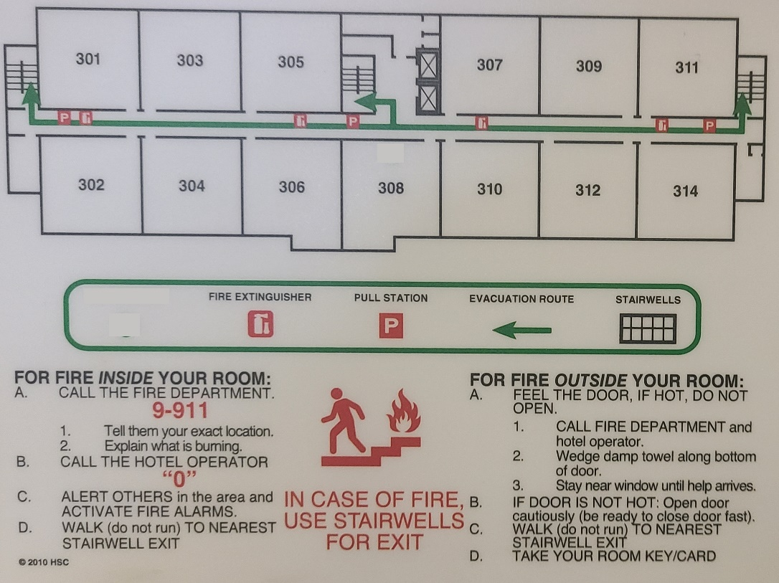
4th Floor (Insert your Hotel Floor Plan here)

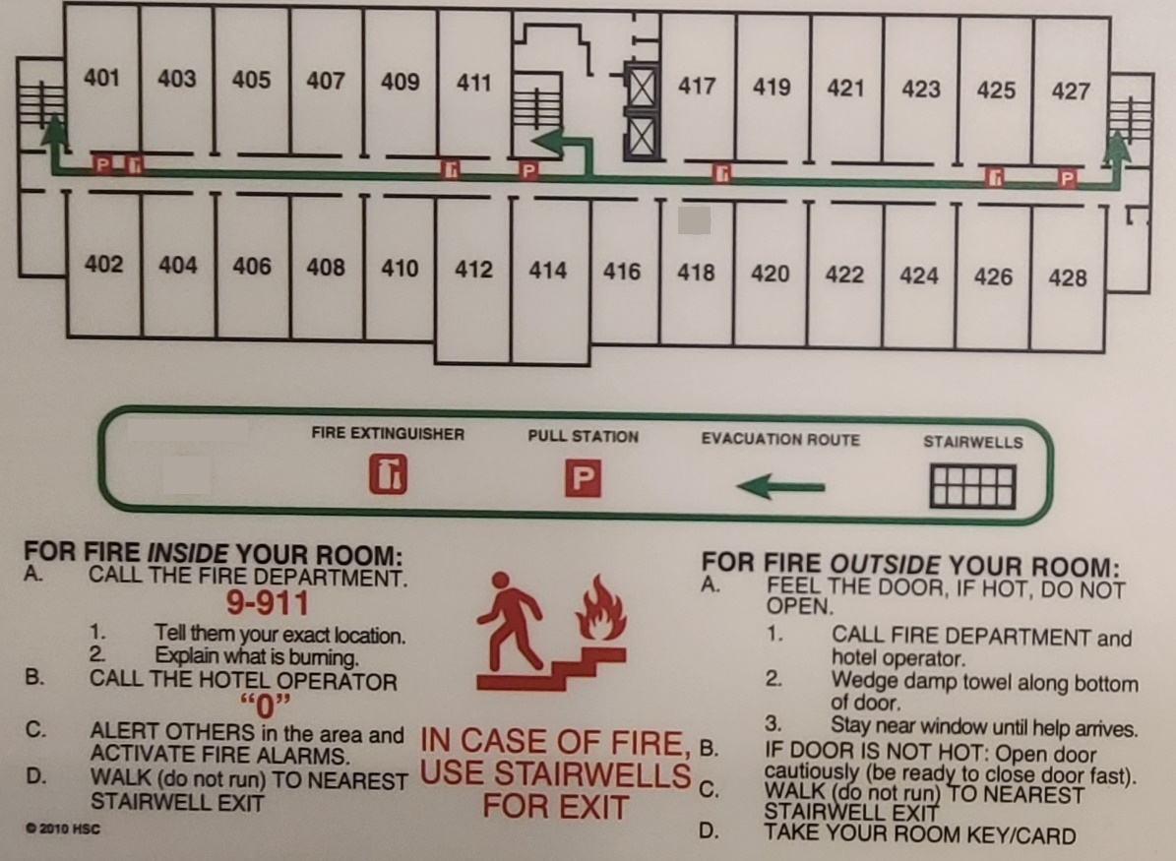

5th Floor (Insert your Hotel Floor Plan here)

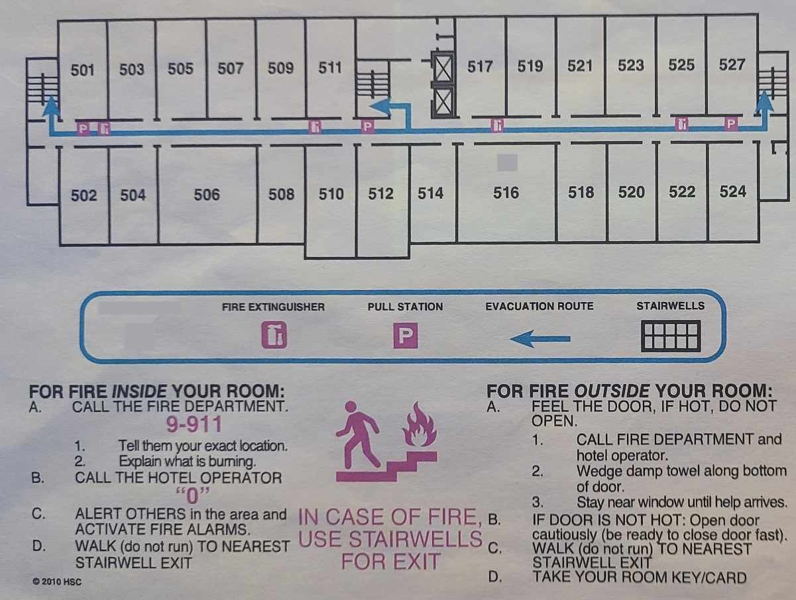

General Fire Evacuation Procedures
If an evacuation is needed due to a fire or other emergency:
- Remain calm, do not rush or panic.
- Gather your keys, medication and personal items if it is safe to do so.
- Close, but do not lock your office door or window if it is safe to do so.
- Evacuate your building at the nearest safe exit, do not use the elevator.
- Test closed doors for heat and/or fire by toughing the door with the back of your hand; do not proceed if hot, seek an alternative exit.
- Once evacuated, proceed to the designated emergency assembly area (EAA) and await further instructions.
- Follow instructions from Building Safety Coordinators and first responders.
- Do not leave the area until you are accounted for and released by first responders.
- DO NOT return for an evacuated building unless told to do so by first responder and/or authorized personnel.
If someone needs assistance leaving the building and you can do so safely, please assist this person out of the building and to your assigned EAA or area of refuge and relay assistance needs to your Building Safety Coordinator or first responder.

Evacuation of Persons with Disabilities and/or Access and Functional Needs:
- Persons with Disabilities and/or Access and Functional Needs (D/AFN) are urged to self-identify and to determine evacuation routes and methods, areas of refuge, and other emergency planning needs before an emergency occurs.
- Establish a “buddy system” whereby disabled and non-disabled colleagues work together to ensure the safe evacuation of all building occupants and relay assistance needs to first responders.
- In many cases, evacuation from the building may not be feasible or advisable. Evacuate when the fire alarms are activated, directed by emergency personnel, or danger is imminent.
- Proceed to the nearest safe exit, implement your individual emergency plan and request assistance from others in the area if exit is difficult or obstructed, do not use the elevator.
- If unable to evacuate the building:
  - Take safe refuge in a fire-rated stairwell and close the door to keep smoke out.

FIRE or Explosion

Precautions
- NEVER treat a Fire Alarm as a “False Alarm” or “Just a Drill”.
- An immediate readiness to evacuate is essential.
- Fire extinguishers should only be used by trained personnel to fight small fires.
- Never enter a room if the door is warm to the touch or where there is a fire or if the room is filled with smoke.

During
- Evacuate the building to the designated emergency assembly area and perform head count to ensure all building occupants are accounted for.
- Pull the fire alarm and warn others nearby as you are leaving. Encourage others to evacuate with you and assist persons with disabilities or access and functional needs.
- FD Take Emergency Binder / Bucket / Downtime Report
- Close doors and windows if time permits.
- Manager Any Departments If able knock-on doors
- Housekeeping - Move Carts into room and close door.
- Take your personal items (bag, wallet, keys, etc.) if these items do not hinder your ability to exit the building quickly.
- Move away from the fire and smoke whenever possible.
- Touch closed doors with the back of your hand to test for heat; do not open them if they are hot.
- Use stairs only; do not use elevators.

After
- Inform first responders of any trapped, injured or need assistance.
- Do not re-enter the building until you have been instructed to do so by first responders.

Trapped in a Room
- Close as many doors as possible between you and the fire.
- Wet and place cloth material around or under the door to prevent smoke from entering the room.
- Be prepared to signal to someone outside.

Caught in Smoke
- Drop to your hands and knees and crawl towards an exit. Stay low as smoke will rise to ceiling level.
- Be familiar with buildings you frequent and know where your exit points are; vision will be limited.

Forced to Advance through Fire
- Hold your breath.
- Move quickly.
- Cover your head and hair.
- Keep your head down and your eyes closed as much as possible.
- Be familiar with buildings you frequent and know where your exit points are; vision will be limited.

If Clothing Catches Fire
- Stop.
- Drop.
- Roll.

FIRE CONTINUED

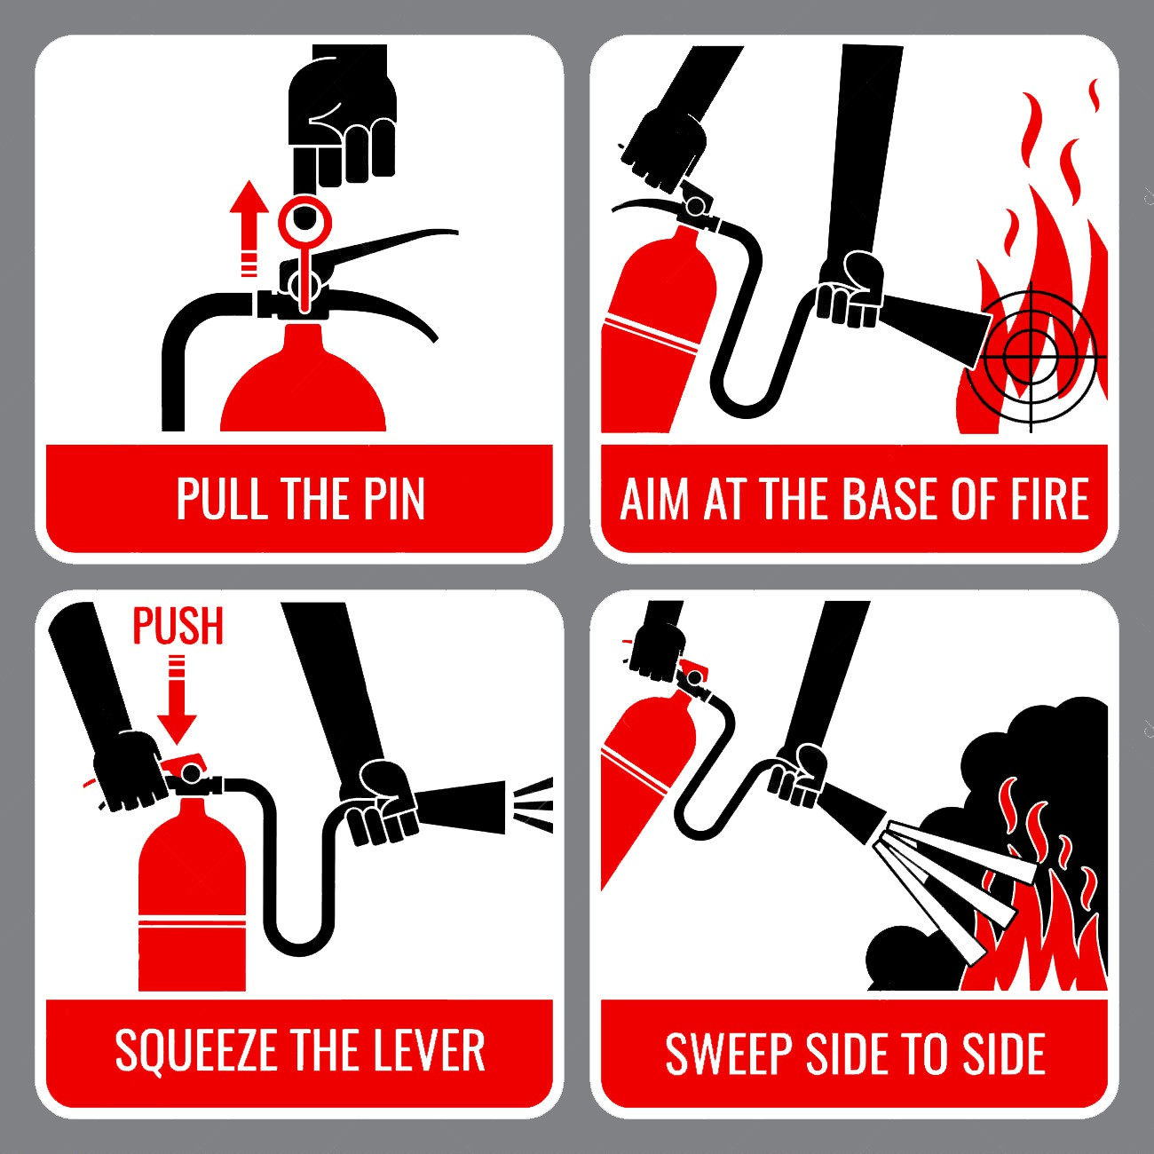
Using a Fire Extinguisher
Trained persons may choose to use a fire extinguisher to extinguish very small, contained fires. This should be done only if you are trained, confident in your skill, and it can be done safely. If you have any doubt, evacuate.

Remember PASS:
Pull the safety pin from handle.
Aim at the base of fire.
Squeeze the trigger handle.
Sweep from side to side at base of fire.

GUEST INJURY

If a guest is injured or reports they were injured on property, fill out an incident report as soon as possible. (include any witness statement)
If medical treatment is sought, then be sure to indicate that in the report. If guest declines medical treatment, put on form.
Guest Name, Room Number, Guest Phone Number and Details of incident.

A copy of the report must be sent to:

The Insurance Company will contact the guest. No info on property.

CORPORATE EMERGENCY NOTIFICATION
All locations worldwide are required to contact the corporate public relations and risk management departments in the event of, but not limited to:
Fire
Natural disaster
Multiple injury (guest or employee) to include food poisoning.
A guest death
Employee work-related death or injury of a serious nature
Armed robbery
Guest assaults of any nature
Bomb threats
Active Shooters
Any other event that could result in media attention.

ACTIVE SHOOTER
An active shooter is an individual actively engaged in killing or attempting to kill people in a confined and populated area. In most cases, active shooters use firearms(s) and there is no pattern or method to their selection of victims.
Active shooter situations are unpredictable and evolve quickly. Typically, the immediate deployment of law enforcement is required to stop the shooting and mitigate harm to victims. Other times, individuals at the site of an attack take action to mitigate the threat (though this is advised only as a last resort).
RUN (evacuate)
- Evacuate regardless of whether others agree to follow.
- Leave all non-lifesaving belongings behind.
- Help others escape, (if possible, use buddy system).
- As soon as possible and safe, notify 9-1-1.
- DO NOT activate a fire alarm to alert others of an active shooter as it may put others in danger.
- Prevent individuals from entering an area where the active shooter may be.
- Keep hands visible to responding law enforcement.
- Follow the instructions of any law enforcement or first responders.
- DO NOT attempt to move wounded people.
- Establish a “buddy system” whereby disabled and non-disabled colleagues work together to ensure the safe evacuation of all building occupants and relay assistance needs to first responders.
HIDE
- Hiding places should be out of the active shooter’s view.
- Silence cell phones (turn off vibrate).
- Turn off any source of noise (i.e. computer, televisions, assistive devices).
- Pull down shades or window coverings.
- Remain quiet.
- Lock the door, turn off lights, and blockade the door with heavy furniture.
FIGHT (take action against the active shooter as last resort)
When evacuating the premises is not possible, hiding is not an option and an individual’s life is in imminent danger, the last resort should be to disrupt and/or incapacitate the active shooter(s).

ACTIVE SHOOTER CONTINUED
Individuals choosing to take action and fight need to commit and act as aggressively as possible against the active shooter(s). This action should be decisive, without hesitation and encompass the following:
- Improvising weapons from nearby items (e.g. fire extinguisher)
- Yelling and throwing items
- Fighting as best they can within their ability.
- Having a “Not Today” attitude (deciding that today is not the day they are going to die)
Establish a “buddy system” whereby disabled and non-disabled colleagues work together to ensure the safe evacuation of all building occupants and relay assistance needs to first responders.
When Law Enforcement Arrives
Law enforcement’s role is to stop the active shooter as soon as possible, which means officers will proceed directly to the area in which the last shots were heard without stopping to help injured persons.
Officers will usually arrive in teams and may wear regular patrol uniforms or external bulletproof vests, helmets, and other tactical equipment. They may be armed with rifles, shotguns, and handguns. Officers will shout commands, provide non-verbal instruction, and may push individuals to the ground for their safety.
Individuals in an active shooter situation can assist law enforcement during their response by doing the following:
- Putting down any items in their hands (e.g., cell phone, bags, jackets).
- If possible, immediately raising their hands and spreading fingers.
- Always keep hands visible.
- Avoid quick movements toward officers, such as holding on to them for safety.
- Avoid pointing, screaming and/or yelling.
- Avoid asking officers for help or directions.
To avoid causing additional fear, stress or emotional strain it is critical for individuals with a disability or Access and Functional Need and their support or buddy system partner(s) to be aware of how law enforcement will respond to an active shooter incident.

BOMB THREAT
Person receiving call should:
  - Contact 9-1-1 (local authorities) immediately.
  - Be calm and courteous and notify security while the caller is still on the line.
  - Try to keep the caller on the line as long as possible. Ask that the message be repeated and write every word the caller says. The operator should have a copy of the bomb threat form (later in this section) on file at his or her desk to use in case of bomb threats.
  - Try to determine the location of the bomb and when it will explode. Tell the caller that innocent people may be injured.
During the Search:
  - The search should be conducted under the direction of local authorities using personnel familiar with the area being searched (i.e., banquet employees search the ballroom).
  - Radios should NEVER be used.
The primary decision to evacuate should normally be made under the direction of local authorities.

BOMB THREAT CHECK LIST
The following information is to be recorded by a bomb threat message recipient during or immediately after the threat is communicated:
ASK
- When is the bomb going to explode? • What is your name?
- Where is it now? • What is your address?
- What does it look like? • Exact wording of threat:
- What kind of bomb is it? • Name of caller? (if known):
- What will cause it to explode? • Number from which call was originated:
- Did you place the bomb? Why? • Male or Female:
CALLER’S VOICE
□ Calm □ Normal □ Angry □ Distinct □ Clearing Throat
□ Excited □ Slurred □ Deep Breathing □ Slow □ Stutter
□ Lisp □ Raspy □ Deep □ Ragged □ Cracked Voice
□ Disguised □ Familiar □ Accent □ Nasal
Male or Female: Ethnicity or accent: Age:
Name of recipient of call: Number at which call received:
Time:
Date:
Additional Comments:

BOMB THREAT CHECK LIST CONTINUED
BACKGROUND SOUNDS
□ Street noise □ Animal noise □ Clear □ Static □ Music
□ House noise □ Motor □ Office noise □ Factory noise □ Voices
□ PA System □ Local □ Long Distance □ Booth □ Other
THREAT LANGUAGE
□ Well-spoken □ Profane □ Irrational □ Incoherent □ Taped
□ Message read by threat maker

ROBBERY/THEFT
Person being robbed should:
  - Remain calm.
  - Follow instructions explicitly, including handing over cash and valuables. Do no more and no less.
  - Not take any unnecessary chances or try to be heroic.
  - Try to remember as much about the assailant as possible. Try to memorize features, dress, accent, etc. Look specifically for any unusual characteristics like scars or tattoos.
  - Try to determine approximate age, height, weight, build, color and length of hair, color of eyes, complexion, whether the assailant has a beard or mustache, etc.
  - If possible, when the assailant leaves the building, note the mode of transportation. If the escape vehicle is clearly visible, look for a license number and the color and make of the car. Note any unusual features about the vehicle, and the direction of travel.
  - Not chase after the robber.
  - Call police.
  - Complete the robbery description form as soon as possible after the crime. Do not divulge the dollar amounts taken during the robbery to the media. (This keeps the amount out of the newspapers and lessens the chance that another robber will take note of the cash your hotel holds.)

ELEVATOR EMERGENCIES
IN CASE OF A STALLED CAR, DO NOT ATTEMPT TO REMOVE OCCUPANTS. CALL THE FIRE DEPARTMENT AND/OR THE ELEVATOR COMPANY.
Coordinate with the Fire Department in advance to make sure they are trained for, and will respond to, elevator emergencies in your hotel.

SEVERE WEATHER
Severe weather can happen anytime, in any part of the country. Severe weather can include hazardous conditions produced by thunderstorms, including damaging winds, flooding and flash flooding, and Hurricane storms associated rain and strong winds.
During
Heavy Rains and Flooding
- While outside, avoid walking, biking, driving, or traveling through moving water.
- If it has been raining for several hours or steadily for several days, be alert to the possibility of a flood.
- Be aware that flooding may occur and must move to higher ground. Do not wait to move.
High Winds
- Remain inside away from windows and doors when possible.
- Avoid areas with tall trees to safeguard against falling branches.
- Stay clear of sagging or downed power lines.

WEATHER EMERGENCIES - HURRICANES

Hurricane Alerts
The Weather Service utilizes two alert system designations:

Hurricane Watch
A hurricane watch is issued when the following conditions are possible: storm surge, coastal flooding, river flooding AND winds of 74 mph or higher. A watch is issued when the storm is 24 to 36 hours from landfall. This is the time to put plans into action.

Hurricane Warning
A hurricane warning is issued when the following conditions are occurring or imminent: storm surge, coastal flooding, river flooding AND winds of 74 mph or higher. A hurricane warning implies that hurricane conditions are expected within 24 hours.

In the eastern Pacific, hurricanes begin forming by mid-May, while in the Atlantic, Caribbean, and Gulf of Mexico, hurricane development starts in June. For the United States, the peak hurricane threat exists from mid-August to late October, although the official hurricane season extends through November. Over other parts of the world, such as the western Pacific, hurricanes can occur year-round.
Know your hurricane season. Review your emergency plan. Check inventory and rent
necessary vehicles four or five days in advance. Monitor the radio.
During a hurricane, beware of the eye of the storm. Winds may completely subside and skies may clear, but winds will rise rapidly from the opposite direction once the eye has passed.
Be alert for flooding, which often accompanies hurricanes. Be sure you have a battery-powered, weather radio to monitor storm conditions. Power outages are common in hurricanes.

Questions are divided into the following categories: In Case of Hurricane Watch
In Case of Hurricane Warning
In Case of a Shut-down During the Eye of the Storm
During the Second Half of the Storm After the Storm

In Case of Hurricane Watch

 | Day Shift | Evening Shift | Night Shift | Weekends/ Special
1. Who is responsible for purchasing plywood, plastic, or other emergency supplies?
2. Who checks to make sure all windows are closed?
3. Who secures loose property?
4. Who monitors the storm advisories issued by the National Weather Service?
5. Who notifies all departments of the watch?
6. Who will meet with local authorities to conduct a pre-planning session to coordinate the plan?
7. If staff members are off-property at the time of the emergency, how will they be contacted and advised of the situation?

 | Day Shift | Evening Shift | Night Shift | Weekends/ Special
8. Who makes sure enough emergency supplies (food, paper plates, water, plastic knives, forks, spoons) are available if hotel is not evacuated?
9. Who notifies guests of the latest weather updates?
10. Who is responsible to notify employees to make preparations at home so they will be available to your facility when the hurricane is imminent?
11. Who is responsible for ensuring clear roof drains and removing debris?

In Case of Hurricane Warning

Note: If instructed by local authorities, you are obligated to evacuate the property to avoid injuries to employees and guests. The following should be considered:
- Where will the hotel emergency command post be located?

- Where will the designated safe area be located (away from windows, with all interior walls above anticipated flood level, if possible)?

 | Day Shift | Evening Shift | Night Shift | Weekends/ Special
3. Who checks emergency equipment to ensure it is working properly?
4. Who brings flashlights, batteries, and other equipment to the designated safe area?
5. Who gathers extra linen and pillows for safe area?
6. Who fills containers with fresh water or purchases bottled water?
7. What provisions will be made for storm victims?
8. What provisions will be made if the property is designated as a shelter by local authorities?
9. Who keeps guests advised of the situation?
10. Who monitors rising water in case guests need to be moved to higher floors?
11. Who keeps a battery- powered radio with extra batteries and where?

In Case of Operational Shutdown and Evacuation

 | Day Shift | Evening Shift | Night Shift | Weekends/ Special
1. Who decides if conditions warrant an evacuation? (Follow local authorities’ directions.)
2. In what order will departments be shut down?
3. Under what circumstances will an emergency crew remain on the premises during the hurricane? Who will be on the crew?
4. Who notifies employees/guests of an evacuation, and how?
5. If a crew remains on the premises, how will emergency supplies be provided (nonperishable food, first aid equipment, lighting, radio receivers, stored drinking water)?

During the Eye of the Storm
When the eye of the storm passes over, the weather may be clear and the sun may be shining. But you are only through half of the storm.

 | Day Shift | Evening Shift | Night Shift | Weekends/ Special
1. Who checks the buildings and grounds and makes emergency repairs? Who secures anything loose or broken?
2. Who should attempt to clean damaged areas inside the property to lessen damage?
3. Who checks roof drains to ensure they are still open and clear of debris?

During The Second Half of The Storm
The winds will change direction during the second half of the storm. In case of flooding, be prepared to evacuate to a higher floor. Someone should continue to monitor the radio as long as possible.

After the Storm

 | Day Shift | Evening Shift | Night Shift | Weekends/ Special
1. Who ensures that all guests and employees are safe?
2. Who makes an immediate damage assessment?

 | Day Shift | Evening Shift | Night Shift | Weekends/ Special
3. Who temporarily repairs any openings in walls or the roof to minimize water/wind damage?
4. Who clears roof drains to prevent water from collecting on the roof?
5. How will employees be notified to return to work (i.e., radio)?

PRE-HURRICANE CHECKLIST
Plan for utilities shutdown, if necessary.
Inspect roof edging strips, gutters, flashing, covering, and drains.
Inspect sign and stack supports, guy wires, and anchorages.
Check for weak door and window or hardware. Expedite necessary repairs.
Protect windows from flying debris.
Protect important records from weather damage.
Update important backup records and move them to a location not vulnerable to the same incident.
Fill aboveground tanks to capacity with product or water to minimize wind damage (see Flood Checklist for underground tanks).
Anchor yard items that can be moved by high winds, such as trailers, lumber, or loose yard storage. Move stored materials inside, if practical.
Assemble the following supplies and equipment at a central, secure location:
Emergency lighting Lumber and nails Tape for windows Sandbags
Roofing paper Caulking compound Tarpaulins/Plastic
Power and manual tools Shovels and axes
Chain saws Buckets Hard hats Goggles
Leather gloves Bull horn
Two-way radios with extra charged batteries

Ensure that the emergency crew remaining on the premises has the following:
Nonperishable food First aid equipment Lighting
Radio receivers
Stored drinking water
Fill emergency generator fuel tanks.

Inspect all fire protection equipment to be sure it is in service. Clean out drains and catch basins.
Fill all vehicles with gasoline at least 24 hours in advance.

Be sure to prepare the Flood Checklist, as well as the Hurricane Checklist.

WEATHER EMERGENCIES - FLOODING

General Information
Flooding is defined as the rise and overflow of a body of water that covers land not usually under water. Flooding may take place suddenly, when water is suddenly released, as in a flash flood. Or it may occur slowly, as bodies of water swell and spill over their banks.
Flooding does not only occur with weather emergencies. Flooding can be created by broken or frozen pipes, or leakage.

Flood Watch
Imagine...
Your hotel enjoys a beautiful view at a bend in the river. Spring rains have been heavier than usual. Thirteen of the riverfront guest bungalows have nearly three feet of water in them, and three eight-foot potted palms just floated down the front driveway...

A flood watch implies that a flood is a real possibility but is not imminent.

Flood Warning
A flood warning implies that a flood is imminent or is in progress and that immediate precautions should be taken.

Flash Flood Warning
A flash flood warning implies that a flash flood is imminent or is in progress and that immediate precautions should be taken. A flash flood is a sudden, violent flood after a heavy rain.

 | Day Shift | Evening Shift | Night Shift | Weekends/ Special
1. Who monitors storm advisories issued by the National Weather Service?
2. Who notifies all departments of the warning?
3. Who updates important backup records and moves them to an area not vulnerable to flooding?
4. Who anchors yard items that can be moved by flood waters, or moves items inside, if practical?
5. Who assembles emergency supplies at a central, secure location? (Gloves, portable pumps and hoses, emergency lighting, lumber and nails, sandbags, mops, buckets and squeegees, tarpaulins, power and manual tools, shovels and axes, etc.)
6. Who is on the emergency crew remaining on the premises?
7. Who identifies vulnerable locations for sandbag placement?

8. Who moves important machinery, records, food, etc., to higher elevations?
9. Who shuts off flammable and combustible liquids at their source to prevent spillage from broken pipes?
10. Who shuts off electrical power when the building is in imminent danger of flooding?

PRE-FLOOD CHECKLIST
Update important backup records and move them to a location not vulnerable to flooding.
Anchor yard items that can be moved by floodwaters, such as trailers, lumber, or loose yard storage. Move stored materials inside, if practical.
Assemble the following supplies and equipment at a central, secure location:
Portable pumps and hose
Emergency lighting
Lumber and nails
Sandbags (sand source)
Mops and squeegees
Tarpaulins
Power and manual tools
Shovels and axes
Water quality test kit
Bull horn
Gloves
Ensure that the emergency crew remaining on the premises has the following:
Nonperishable food
First Aid equipment
Lighting
Radio receivers
Stored drinking water
Fill emergency generator fuel tanks.
Inspect all fire protection equipment to be sure it is in service.
Place sandbags at vulnerable openings. Divert water from critical areas such as holes in foundations, doorways, and sills.
Move important machinery, stock, and reports to higher elevations. By knowing the past flooding history of the area, reasonably safe areas can be selected.
Shut off all flammable and combustible liquid lines at their source to prevent the discharge of such liquids from piping broken by floating debris. Support exposed piping properly.
Shut off electrical power at the main building disconnect when that building is in imminent danger of flooding.

Fire or Explosion
  - Activate and recognize alarm systems (through fire drills)
  - Report discovery of fires (including when to attempt to extinguish a fire, what information to report, whom to notify)
  - Know the location of the emergency command post in case of a fire.
  - Evacuate the property (how employees will be notified to evacuate, how to secure each department, how to identify and help handicapped guests)
  - Use emergency equipment properly.

Injury or Illness
  - Call the correct person after discovering the sick or injured person (police, ambulance, person trained in CPR and First Aid)
  - Know where the name and extension number of the person trained in CPR and First Aid is located.
  - Perform CPR and First Aid
  - Obtain necessary information from the injured person (by using injury or illness form, location of forms)
  - Complete appropriate forms
  - Complete the accident investigation report.
Weather Emergencies— Tornadoes
  - Monitor storm advisories put out by the National Weather Service
  - Know the location of the emergency command post.
  - Communicate emergency information to guests and other employees.
  - Know the location of designated shelter areas.
  - Identify alarm systems.
  - Provide first aid/CPR (at least one employee per shift)

Weather Emergencies— Hurricanes
  - Monitor storm warnings put out by the National Weather Service and follow local authority advisories.
  - Know the location of the emergency command post.
  - Communicate emergency information to guests and other employees.
  - Know the location of designated shelter areas.
  - Identify alarm systems.
  - Provide first aid/CPR (at least one employee per shift)
  - Identify who will bring emergency equipment and supplies to designated safe areas.
  - Identify where the flashlights, battery-powered radio and extra batteries will be kept, etc.
  - Monitor emergency generator fuel levels in case of a shutdown:
  - Identify the order of department shutdown.
  - Identify under what circumstances an emergency crew will stay on the premises, and who will be a part of the crew.
After the Storm:
  - Determine how employees will be notified to return to work.

Weather Emergencies— Flooding
  - Monitor storm warnings put out by the National Weather Service and follow local authority advisories.
  - Identify what emergency supplies to assemble at a central, secure location.
  - Identify openings to be sandbagged, if necessary
  - Identify what machinery and equipment to move to higher ground.
  - Shut off valves for flammable and combustible liquids and gases.
  - Update and move records to areas not vulnerable to flooding.
  - Locate the electrical shut-off valves.
  - Monitor emergency generator fuel levels.
Weather Emergencies— Earthquakes
  - Follow proper evacuation procedures, including where to assemble after evacuation.
  - Shut off power and gas.
  - Contact local authorities to request assistance.
  - Assist in conducting search and rescue for those trapped.
  - Cordon off hazardous areas
  - Provide first aid.
  - Assess damage after the quake.
  - Contact contractors for temporary repair.
  - Identify who will bring emergency equipment and supplies to designated safe areas (including leather gloves)
  - Identify where the flashlights, battery-powered radio and extra batteries will be kept, etc.

Utility Outages
  - Follow procedures to free guests from elevators.
  - Repair the source of the power outage, if appropriate
  - Identify the location of emergency flashlights.
  - Monitor emergency generator fuel levels.
Robbery
  - Never take any action that could jeopardize the safety of hotel employees or guests.
  - Follow the robber’s instructions.
  - Do not resist, and do not block the robber’s exit.
  - Note the physical characteristics of the robber(s). (e.g. clothing, scars, tattoos, hair color, height, weight, race, sex, speech, etc.)
After the robbery:
  - Take immediate precautions to ensure your safety and the safety of nearby employees and guests.
  - Obtain medical assistance, if needed
  - Notify police immediately after the robbery.
  - Limit access to the crime scene
  - Document all information on an investigation report.

Elevator Emergency
  - Not evacuate the elevator car
  - Call the elevator company or fire departments to evacuate the car (including the location of emergency numbers)
  - Follow the procedures for maintaining communication with trapped persons.
  - Contact the General Manager/MOD
  - Complete appropriate reports
Food Poisoning
- Show care and concern. You are in the hospitality business, and you want to exceed your guests’ expectations so being empathetic should be second nature.
- Ensure you get the guest’s contact information. Document the name, address, and telephone number of the guest who complains of an illness.
- Note down the date and time the guest visited your property.
- Document all items eaten in your facility by the guest during the visit in question.
- Obtain the name and address of the physician treating the guest. If the guest has not contacted a physician, encourage him or her to do so.
- Contact the physician to determine if a case of foodborne illness or food poisoning has been diagnosed.
- Notify the local health department immediately if a foodborne illness outbreak is confirmed, so the staff there can assist you in determining the source of the outbreak, as well as identifying affected guests and employees.
- Evaluate and, if necessary, modify your training and certification efforts that relate to the areas involved in the incident.
- Document your efforts and notify your attorney or company manager.
- Secure all the ingredients in the dish with potential contamination.
- If there are more complaints, local health authorities, the CDC, and vendors must be contacted.
- All affected diners must be contacted to offer them assistance and reimbursement.
- Hotel or Management’s obligation now is to clean, contain, and cooperate with local and federal health agencies.

DEATH
How to properly respond to a guest death in your hotel
Whether it is a housekeeper, security officer, or hotel manager who discovers a potentially deceased victim, the first responsibility must always be to check the body to determine that the guest is actually dead and not merely asleep, suffering a stroke or heart attack, or has lapsed into a state of unconsciousness.
Shake the guest and check for a pulse and listen for breathing. Absent these vital signs, notify the hotel switchboard or front desk using a land-line telephone or cell phone. Do not use a two-way radio or walkie-talkie as news of the death will be broadcast over the entire hotel communications network.
The front desk or switchboard will notify the police and the hotel’s security department.
Remember, the guest is dead, speed is not necessarily of the essence here, but discretion is. It is imperative to share word of a guest’s death only to those individuals who need to respond or notify the authorities.
The next step is to exit and secure the guestroom or immediate area. This means leaving the guestroom, locking the door, and awaiting the arrival of hotel management and the police. To preserve the area for investigation and to secure the decedent’s valuables, it is critical that no single employee be left alone in the area where the death occurred.
Once Management arrives, the employee who discovered the body should explain how and when they found the body, what steps they undertook to ascertain the guest was no longer alive, anything else they noticed, and what items in the guestroom or general area they touched.
Have a manager escort the employee to a secure location and wait with them to gather their composure and await questioning by police.
Have a front desk agent or security officer stationed in the lobby to meet responding police and escort them to the location of the guest’s body.
No employee or manager should re-enter the guestroom or area of the body until police arrived unless there is sufficient reason to believe that an unattended baby or child is still located in the room.
At this point it is the hotel’s primary responsibility to secure the location.
Once the police arrive, give them access to the scene and provide them the guest’s registration card and payment information from the front desk. Hopefully, this will enable the authorities to contact the decedent’s next of kin. Have Engineering remove from general service one elevator for exclusive use by police and the coroner.
This elevator should be large enough to accommodate a stretcher so the body may be removed from the hotel. With the assistance of the police, hotel security should inventory all personal items of the decedent found in the guestroom. If the authorities remove the decedent’s property, request that the hotel be issued a receipt for all items removed.
This will protect the hotel from potential theft claims levied by the decedent’s next of kin. If the police or coroner does not remove the guest’s personal property, it is the hotel’s responsibility to do so and safeguard it. Do not remove the decedent’s property until the police or coroner approve.
Once approval is granted, safeguard all of the decedent’s property until it can be returned to the person authorized to receive it. This would normally be the duly appointed executor or administrator of the decedent’s estate. Items of high value should be placed in a safe or safe deposit box.
Death from suicide
The first priority is to ascertain the guest has expired with no hope of resuscitation. If revival is a possibility, contact the front desk or switchboard using the most expedient means and have them call 9-1-1 or the police/emergency response authorities immediately.
Engage in CPR or appropriate first aid measures until emergency services arrive. If it appears that the guest has been expired for a considerable time and you are certain that revival is impossible, do not remain in the guestroom or area.
After notifying the front desk or switchboard on the guestroom phone exit and lock down the guestroom or secure the general area. Await the arrival of hotel management and the police.
Follow the same procedures as described above for death from natural causes or illness. Three unique problems to consider There are three unique aspects that hotels must consider when dealing with situations where guests have committed suicide on property. The first is the “crime scene” aspect.
As committing suicide is essentially a crime in all states, the location where the body is found must remain unadulterated to the extent possible so that the police may conduct a proper investigation.
If the police and/or coroner determine that the guest’s death is actually a result of unassisted suicide, then there is no person alive to prosecute and the investigation ends promptly. But if they determine that the guest was assisted by a second party in their suicide, or perhaps the authorities believe that the guest was the unwilling victim of a criminal act but the scene was arranged to appear as if the guest took their own life, an uncontaminated crime scene will assist the police in furthering their investigation.
Therefore, it is critically important that hotel employees who arrive upon a possible suicide or crime location do not touch any aspect of the scene unless absolutely necessary to save the live of the victim.
Details should only be shared with those who have a legitimate need to know, not with everyone who just wants to know what happened. In any location where a messy death occurred, the hotel will need to sanitize the area. For a guestroom, this will typically involve placing the guestroom out-of-order and replacing all soft goods in the room, including the mattress, linens and perhaps carpeting and draperies.
Case goods and hard surfaces will need to be thoroughly disinfected. This procedure may be more psychological than sanitary in nature, but the hotel has to be able to defend that it took appropriate actions to cleanse a death site before returning it to use by the general public.

Food Poisoning
Food poisoning accusations can have terrible consequences for businesses – especially in the age of social media and instant online reviews. How you handle an accusation matters.
Be prepared
Even if you have a perfect track record as a venue, you should have a contingency plan in place in the event of a food poisoning accusation. The plan should clearly outline the steps to take in such an event – from how to respond to the customer, to how to contact the authorities.
This plan should be written down and every employee should be familiar with it. If a new employee takes the call with a sick and disgruntled customer, you don’t want their response to escalate the situation. That’s why it’s a good idea to incorporate the food poisoning contingency plan as part of your employee training.

Responding to the customer
A food poisoning accusation needs to be taken seriously, and with empathy. But while it’s likely that your first instinct will be to apologize to the customer, it may actually make the situation worse for you.
By apologizing, you are essentially admitting guilt. This leaves you open to legal action that could land your business in big financial trouble – not to mention it could ruin your reputation entirely.
Pinpointing the source of food poisoning can be very difficult. There is a good chance that the customer fell ill from something else. But you do have to take immediate action to respond to the accusation.
Gather the relevant information. Aside from their contact details (so you can get back to them following your investigation) you should ask:
- What they ate and when
- The symptoms they are exhibiting and when they started
- Whether anyone else from their party had the same food
- Whether anyone else from their party is experiencing similar symptoms
- Whether they have seen a doctor for diagnosis
It’s important to let the customer know that you have taken their complaint seriously and will be taking immediate steps to investigate.
As part of your food poisoning contingency plan, it is a good idea to have a customer complaint form that deals specifically with this issue. This will ensure that you will be provided with all the information you need to follow up the matter.

